Week 2: Implementing Security Measures in Node.js
Student:
Course:Cybersecurity Practical
Project: Secure Backend API

1. Objective
The objective of this assignment is to implement security measures in a Node.js backend API. The key goals are:
- Fix vulnerabilities in user input by validating and sanitizing data.
- Secure passwords using hashing techniques.
- Implement token-based authentication using JWT.
- Secure HTTP headers for safe data transmission.
Tip: Screenshot here: Project overview folder in VS Code

2. Project Setup
Step 1: Install Node.js
- Download and install the LTS version from https://nodejs.org.
- Verify installation using:
node -v
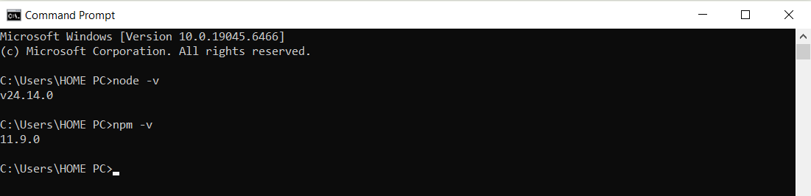
npm -v

Step 2: Create Project Folder
- Folder name: secure-api
- Open folder in terminal:
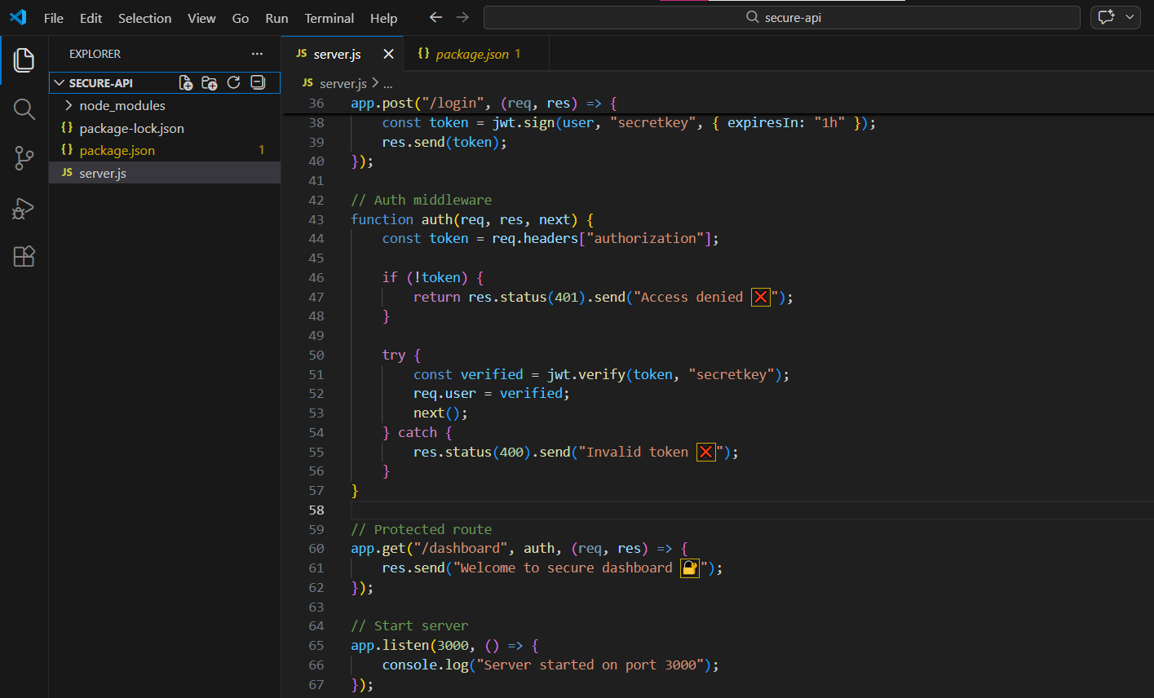
cd path/to/secure-api

Step 3: Initialize Node.js Project
npm init -y
This generates package.json.
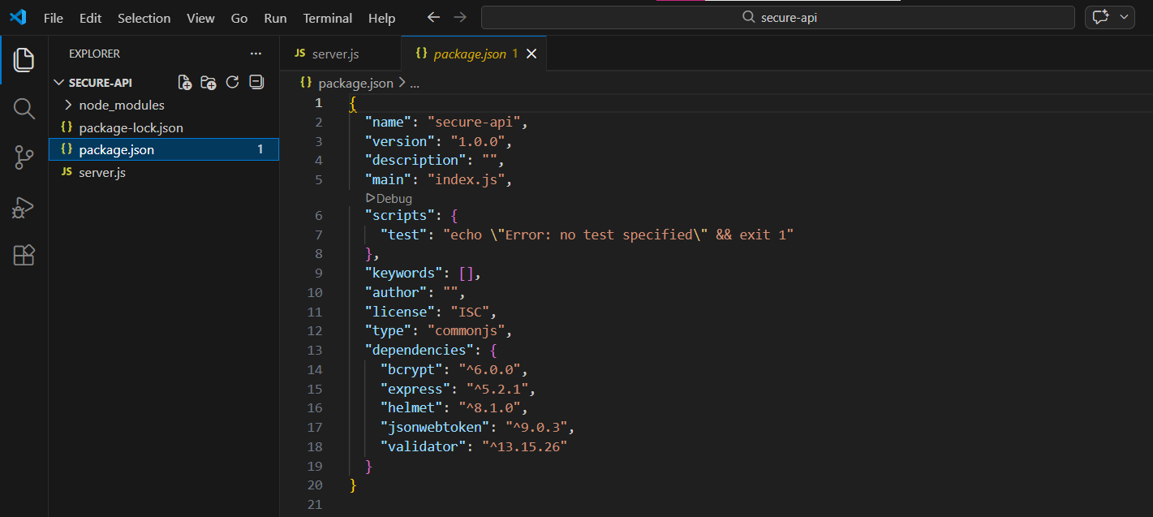

Step 4: Install Required Packages
npm install express validator bcrypt jsonwebtoken helmet
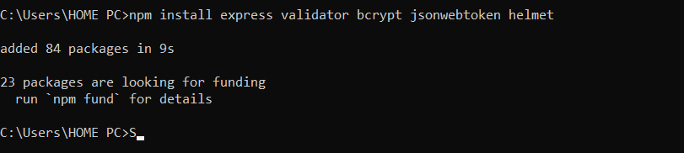

3. Implementing Security Features
3.1 Secure Server Setup
Create server.js with:
const express = require("express");
const helmet = require("helmet");

const app = express();
app.use(express.json());
app.use(helmet());

app.get("/", (req, res) => {
res.send("Server running securely 🚀");
});

app.listen(3000, () => {
console.log("Server started on port 3000");
});
- This sets up a basic server with Helmet for secure HTTP headers.
- Server runs at http://localhost:3000.
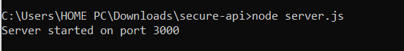
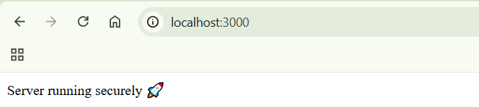

3.2 Input Validation
Using validator to validate email input:
const validator = require("validator");

app.post("/register", (req, res) => {
const { email } = req.body;

if (!validator.isEmail(email)) {
return res.status(400).send("Invalid email ❌");
}

res.send("Email valid ✅");
});
- Ensures user input is valid and sanitized.
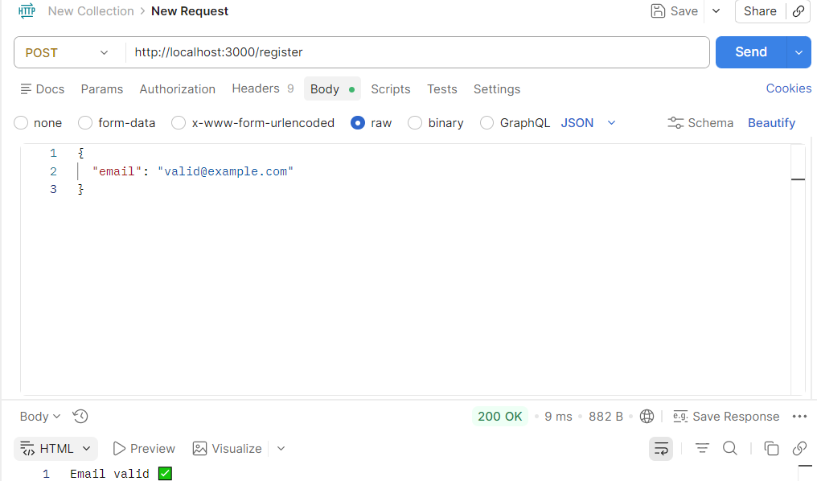

3.3 Password Hashing
const bcrypt = require("bcrypt");

app.post("/hash", async (req, res) => {
const password = req.body.password;
const hashedPassword = await bcrypt.hash(password, 10);
res.send(hashedPassword);
});
- Passwords are stored in hashed form, not plain text.
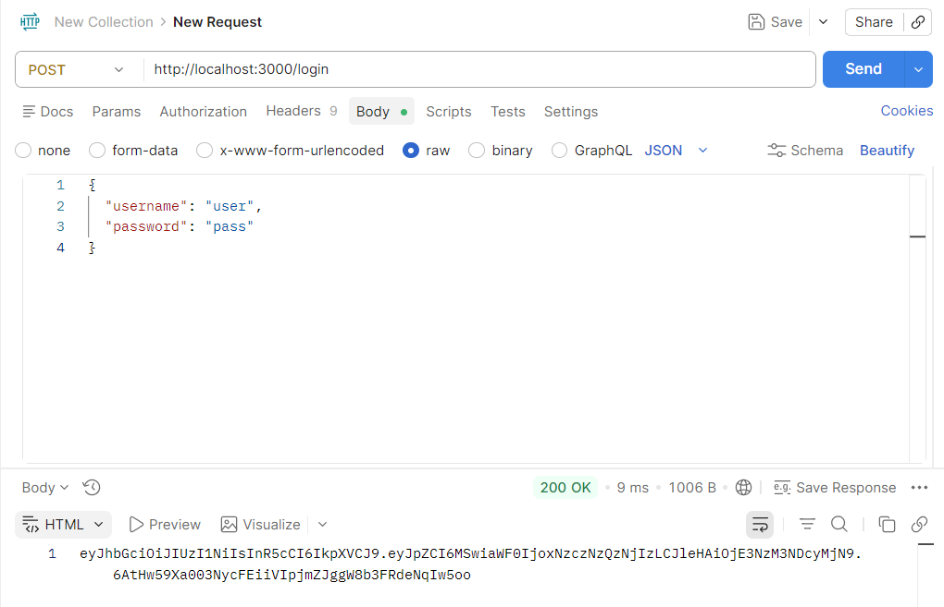

3.4 Protected Route
function auth(req, res, next) {
const token = req.headers["authorization"];

if (!token) {
return res.status(401).send("Access denied ❌");
}

try {
const verified = jwt.verify(token, "secretkey");
req.user = verified;
next();
} catch {
res.status(400).send("Invalid token ❌");
}
}

app.get("/dashboard", auth, (req, res) => {
res.send("Welcome to secure dashboard 🔐");
});
- Only requests with a valid token can access /dashboard.
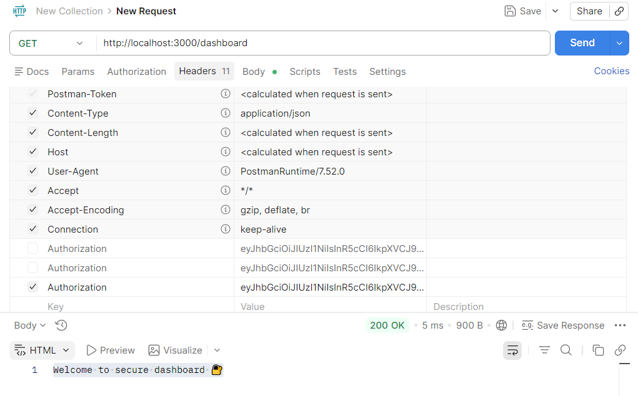

3.5 Secure HTTP Headers
const helmet = require("helmet");
app.use(helmet());
- Protects against common HTTP vulnerabilities.
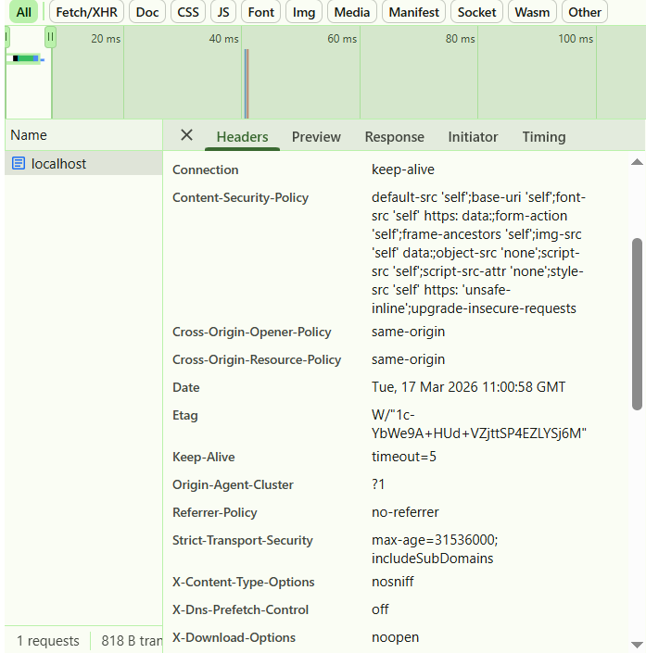
Screenshot : Browser DevTools showing Helmet headers

3.6. Observations
- API is protected from basic vulnerabilities.
- JWT ensures authorized access.
- Password hashing prevents storing plain text.
- Input validation reduces risk of invalid data.

Conclusion
- Successfully implemented input validation, password hashing, token authentication, and secure headers.
- Week 2 objectives are fully completed.
- Server is ready for future database integration & full authentication.

